## horizontal line

Forward Propagation(class8)

10.01.2025

**─**

# Forward Propagation



As discussed there are 26 trainable parameters .

The dataset is :

| cgpa | iq | 10th marks | 12th marks | placed |
| --- | --- | --- | --- | --- |
| 7.2 | 72 | 69 | 81 | 1 |
| 8.1 | 92 | 75 | 76 | 0 |

The prediction is : ( x + b)



Xi1 b11

Xi2 + b12

Xi3 b13

Xi4

4 x 3 transposes 3 x 4 4 x 1 3 x 1

## 

## Layer 1

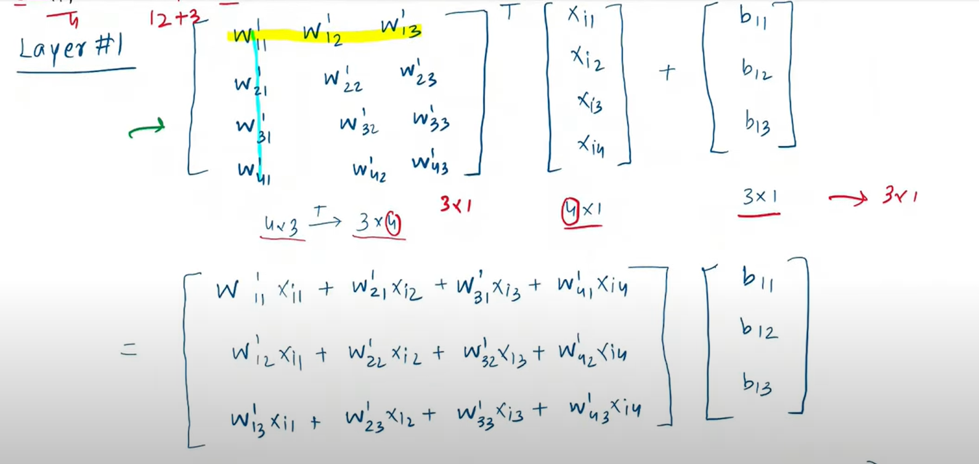

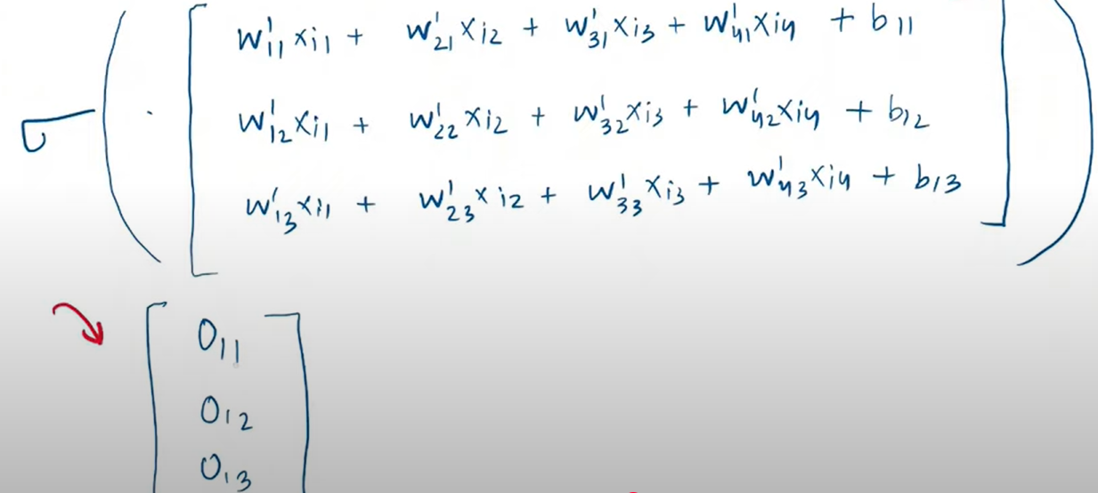

## Layer 2

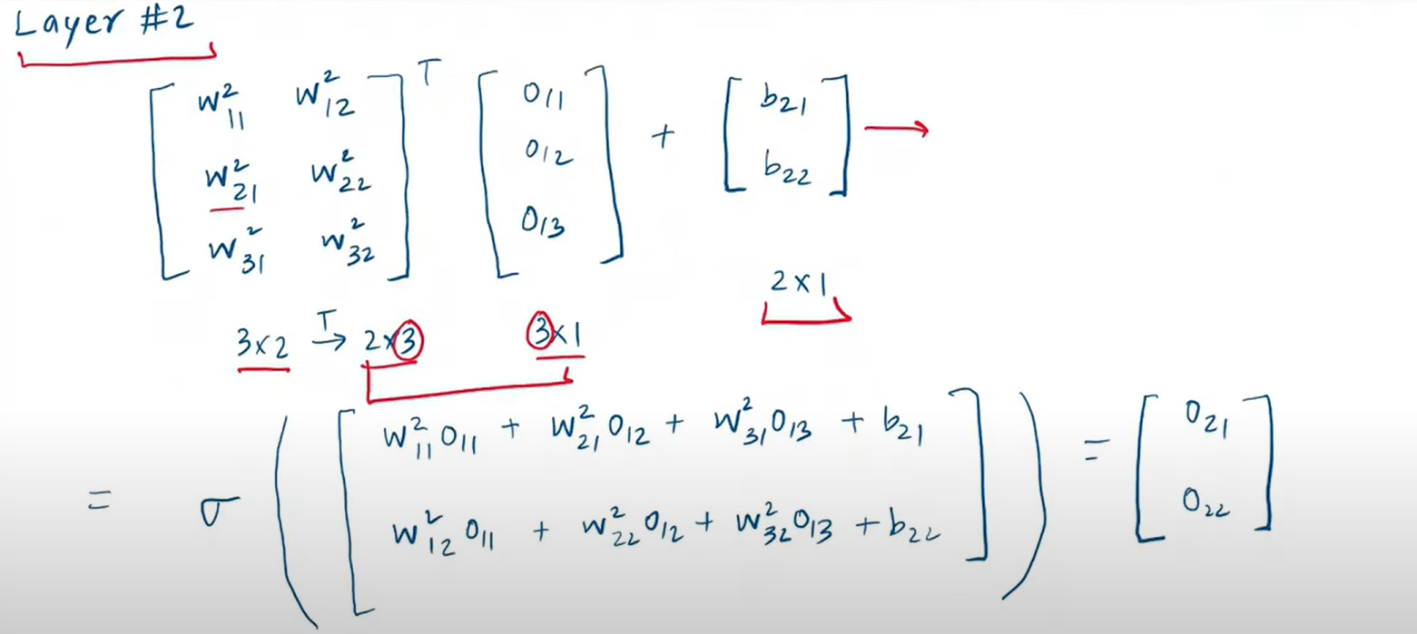

## Layer 3

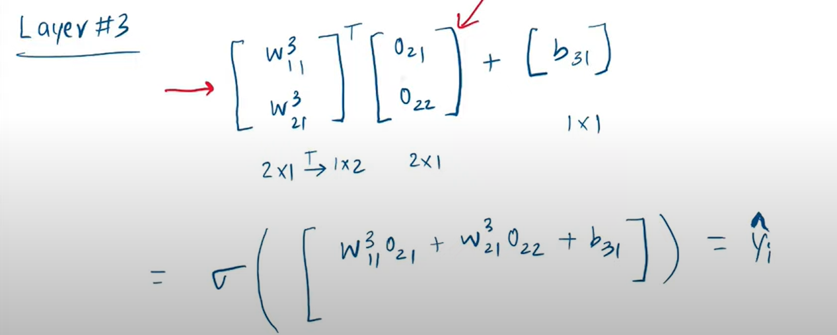

L0 is a[0] , L1 is a[1] , L2 is a[2] , L3 is a[3]

A[1] = (a[0] .w[1] + b[1])

A[2] = (a[1] .w[2] + b[2])

A[3] = (a[2] .w[3] + b[3])